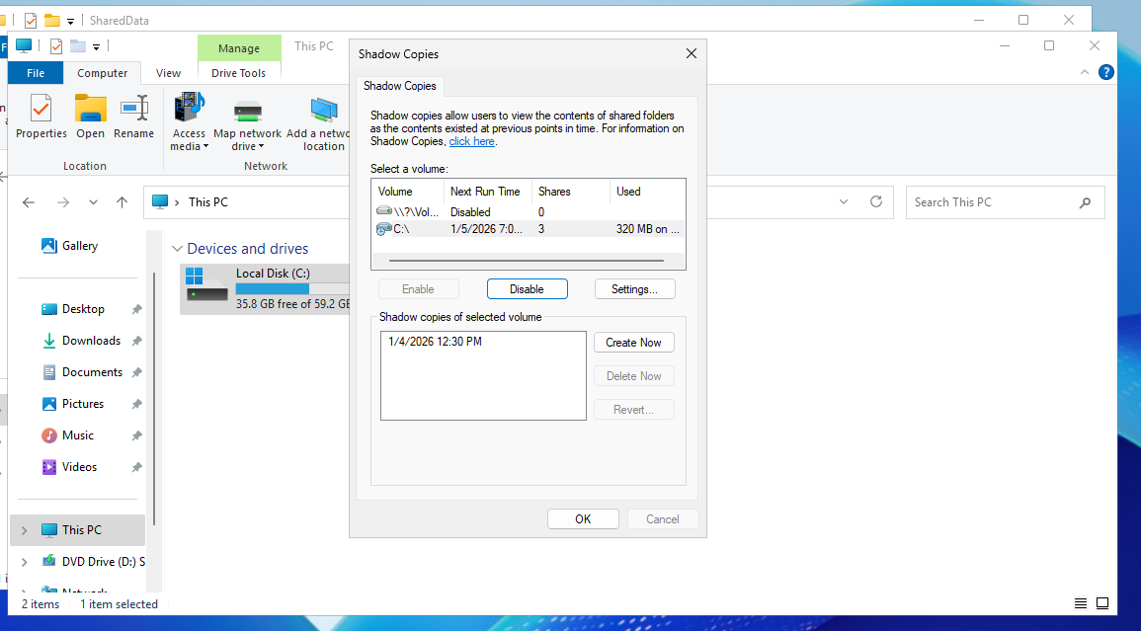
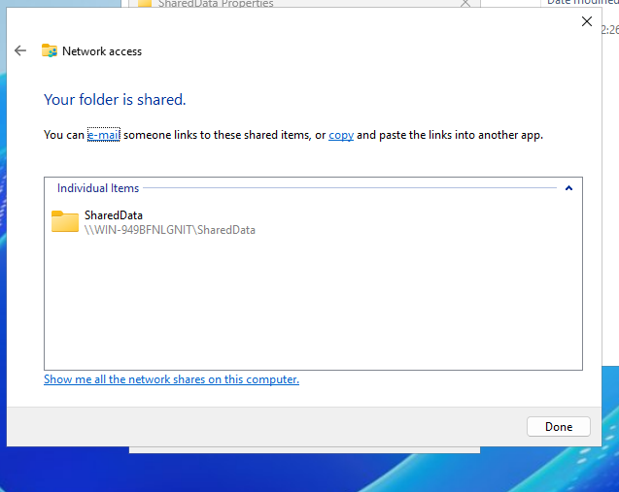
Network Policies – SMB, Firewall, File Shares, and Shadow Copies
A shared folder was created on the server, and Shadow Copies were enabled to allow file recovery.
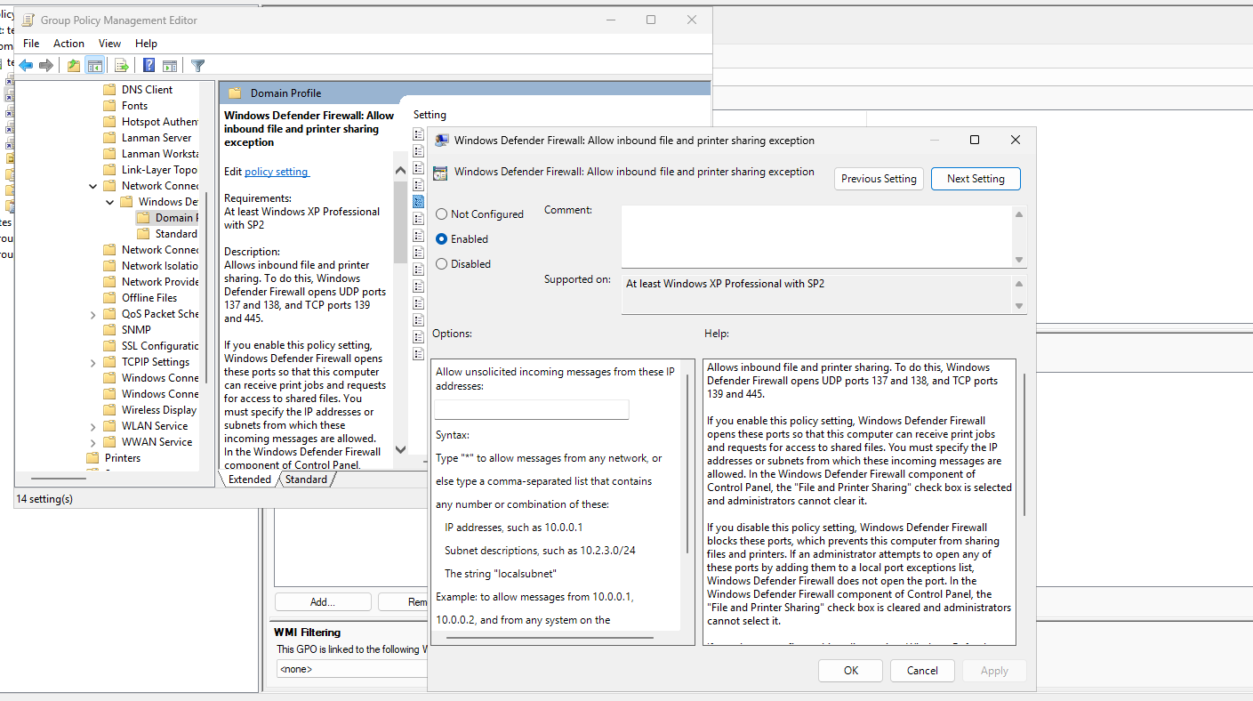
Group Policy Configuration
A Group Policy Object (GPO) was created to enable Network Discovery.
Link-Layer Topology Discovery was also enabled through Group Policy.
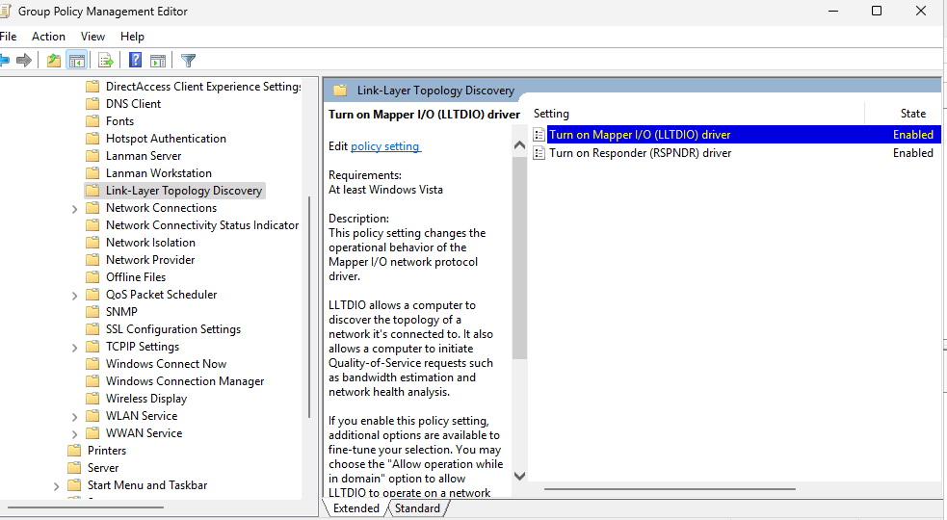Also enabled link layer topology discovery
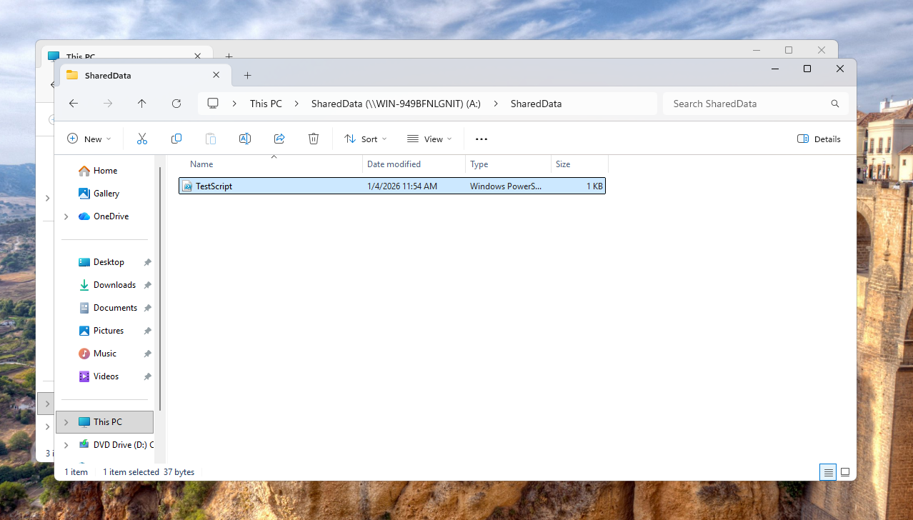
File Share Access
The shared drive was mapped to a domain-joined workstation, and a file was successfully uploaded to the shared folder.
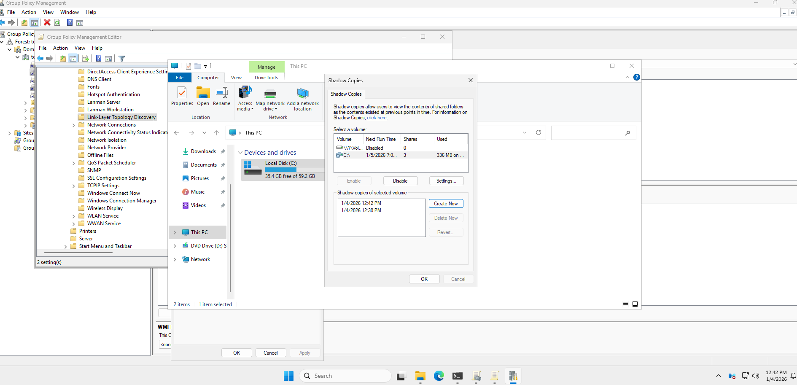
I then created a shadow copy on the DC
Went back to the windows workstation and deleted the file.
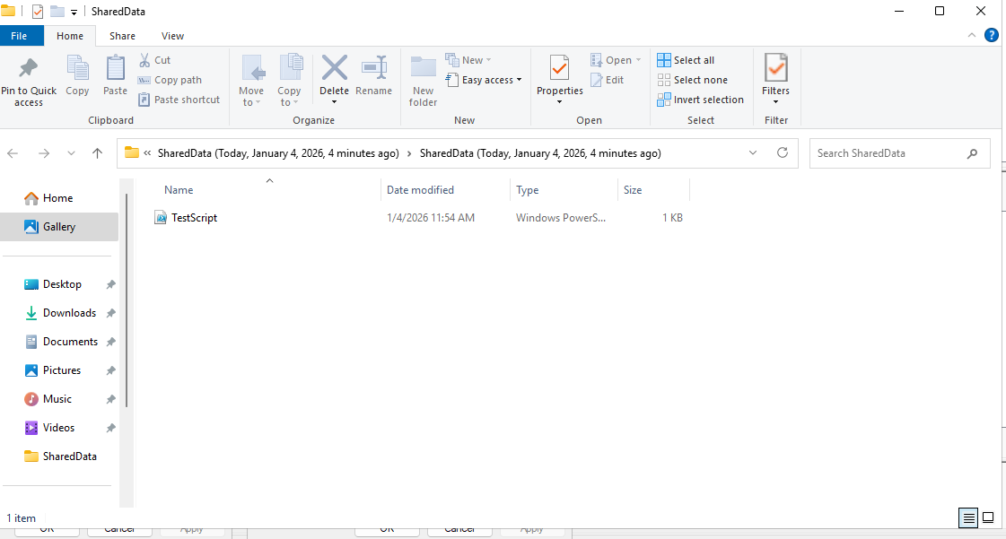
Shadow Copy Creation and Recovery
A shadow copy was created on the Domain Controller. The file was then deleted from the Windows workstation. Using Shadow Copies, the deleted file was successfully recovered, confirming that the configuration was functioning as intended.

